Comparative Study of DFT Simulated and Experimental Powder Raman Spectra of N-Acetylmuramic Acid (NAM)
Date: February 2026
Prepared for: Monthly Review Meeting
Molecular Target: N-Acetylmuramic Acid (MurNAc) – bacterial cell wall biomarker

1. Objective
The objective of this work was to evaluate whether N-acetylmuramic acid (NAM) produces identifiable Raman signatures and to validate DFT-simulated Raman spectra against experimental powder Raman measurements.
Specifically, this study aimed to:
- Identify Raman-active vibrational modes of NAM
- Compare theoretical (DFT) and experimental peak positions
- Verify whether matched peaks correspond to the same molecular vibrations (same chemical bonds)
- Establish diagnostic Raman peak regions for future bacterial detection studies

2. Data Sources
2.1 Simulation Data
- Method: Density Functional Theory (DFT)
- Output: Raman shift (cm⁻¹) vs relative intensity
- Spectral range analyzed: 200–2000 cm⁻¹
2.2 Experimental Data
- Sample: NAM powder
- Acquisition condition: 5% laser power, 20 s integration
- Spectral range analyzed: 200–2000 cm⁻¹
- Raw characteristics: Baseline drift, noise, peak broadening

3. Methodology
3.1 Simulation Data Processing
The simulated Raman spectrum was:
- Limited to the 200–2000 cm⁻¹ fingerprint region
- Normalized to maximum intensity = 1
- Peaks detected using a prominence-based algorithm
Figure 1 shows the DFT-simulated Raman spectrum of NAM with major vibrational peaks labeled.
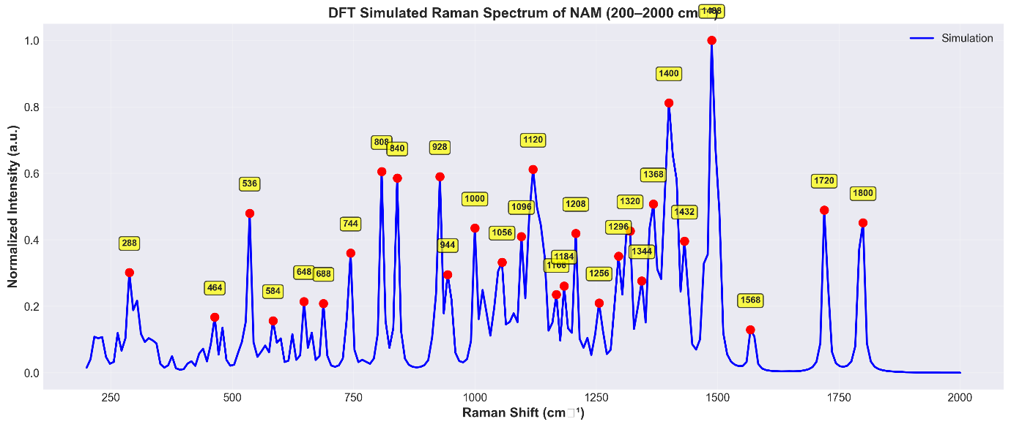
Figure 1. DFT-simulated Raman spectrum of N-acetylmuramic acid (200–2000 cm⁻¹) with labeled peaks.

3.2 Experimental Powder Data Processing
Experimental Raman data were processed using the following sequence:
- Dark subtraction
- Baseline correction (Asymmetric Least Squares, ALS)
- Savitzky–Golay smoothing
- Normalization to maximum intensity = 1
Figure 2 presents the processed experimental powder spectrum with detected peaks.
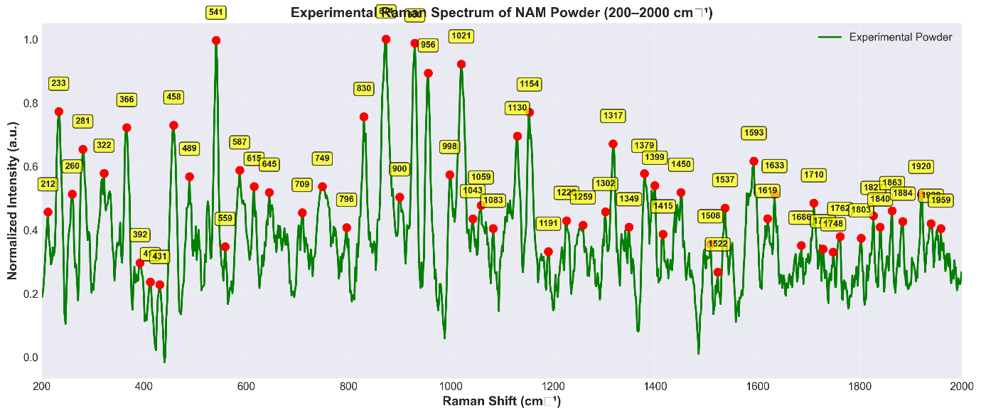
Figure 2. Preprocessed experimental Raman spectrum of NAM powder (200–2000 cm⁻¹).

4. Results and Spectral Comparison
4.1 Overall Spectral Comparison
A direct overlay of normalized simulation and experimental spectra was performed to visualize global agreement.
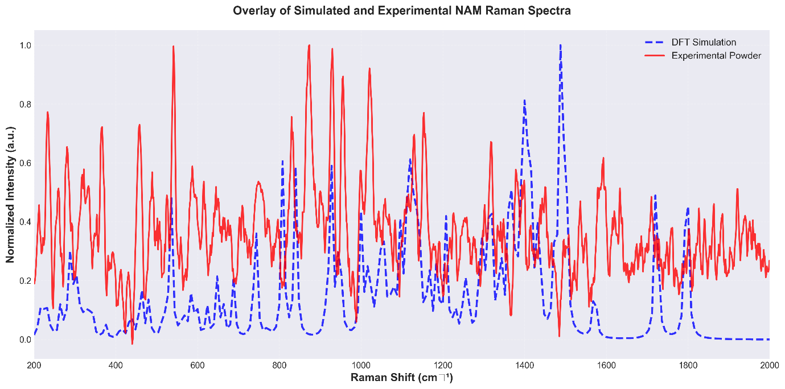
Figure 3. Overlay of DFT-simulated (blue dashed) and experimental powder (red solid) Raman spectra of NAM.
This comparison shows general correspondence in major peak regions, with expected differences in intensity and peak density.

4.2 Independent Spectrum Inspection
To allow clearer visual inspection, spectra were also presented independently.
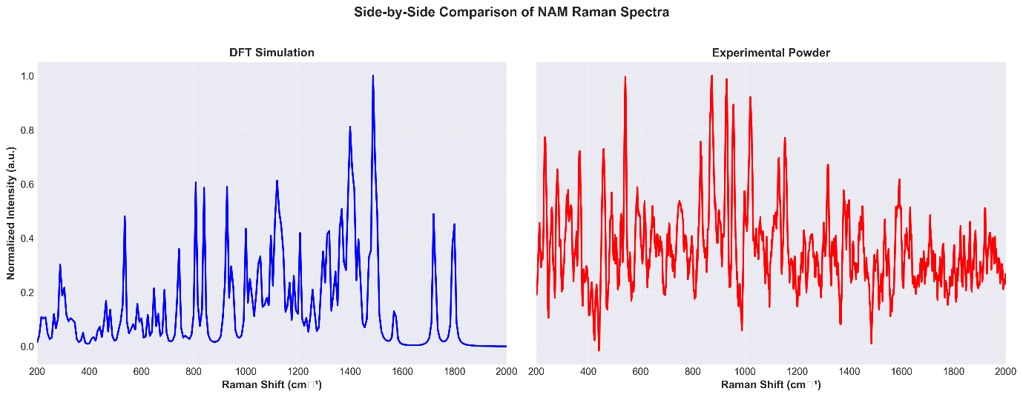
Figure 4. Side-by-side comparison of simulated and experimental Raman spectra of NAM.
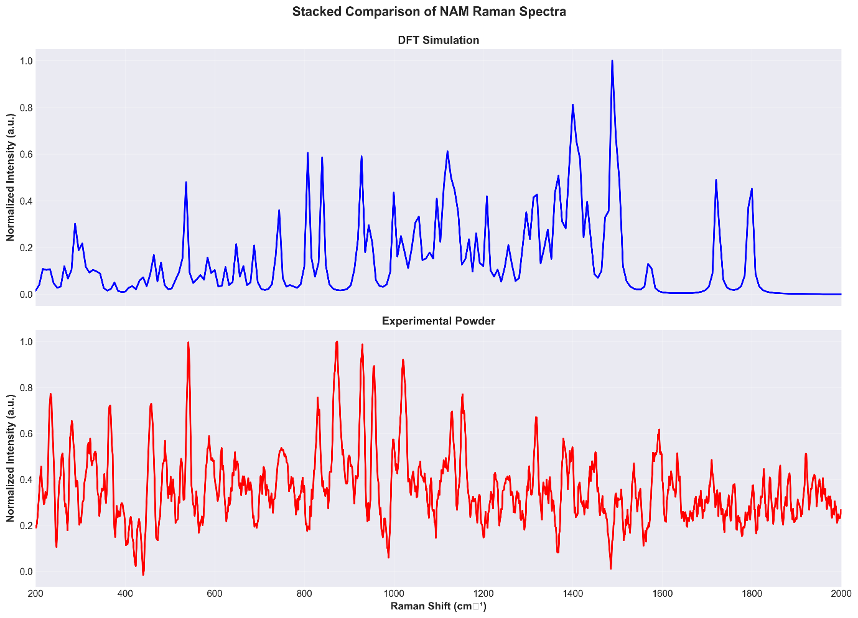
Figure 5. Vertically stacked Raman spectra highlighting relative peak alignment between simulation and experiment.
These views emphasize that peak positions, rather than intensities, are the key comparison metric.

5. Diagnostic Peak Matching and Molecular Validation
5.1 Diagnostic Peak Library
Eleven literature-validated diagnostic Raman ranges corresponding to NAM vibrational modes were used as reference windows for peak matching.
Peak matching was performed using range-based tolerance (±10–20 cm⁻¹), which is standard practice in Raman spectroscopy due to environmental and computational effects.

5.2 Final Diagnostic Peak Validation
The most critical comparison is shown in Figure 6, where diagnostic peak regions are explicitly marked and matched between simulation and experiment.
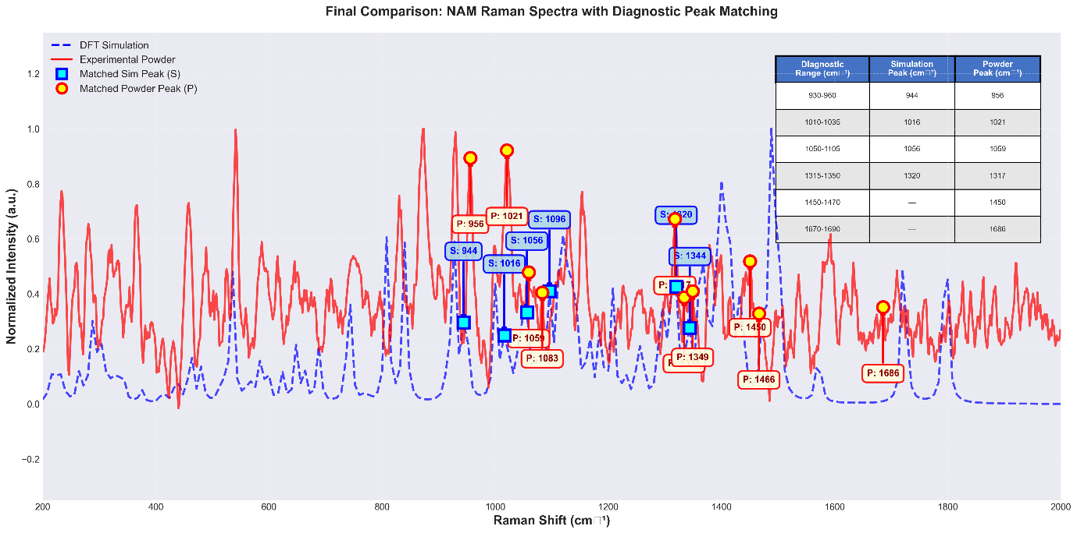
Figure 6. Final annotated overlay of simulated and experimental Raman spectra of NAM with matched diagnostic peaks highlighted.
This figure visually demonstrates that simulation and experiment detect the same molecular vibrations, even when exact peak positions differ slightly.

5.3 Diagnostic Peak Comparison Table
Table 1. Diagnostic Raman peak comparison between DFT simulation and experimental powder spectra of NAM.
Diagnostic Range (cm⁻¹) | Vibrational Assignment | Simulation Peak (cm⁻¹) | Powder Peak (cm⁻¹) | Same Molecular Vibration
930–960 | Lactyl / amide linkage | 944.0 | 955.9 | Yes
1010–1035 | C–C / C–O stretch | 1016.0 | 1020.8 | Yes
1050–1105 | Glycosidic C–O stretch | 1056.0 | 1059.2 | Yes
1315–1350 | CH bending | 1320.0 | 1317.5 | Yes
1450–1470 | CH₃ deformation | — | 1450.3 | Experiment only
1670–1690 | Amide I (C=O) | — | 1685.7 | Experiment only

6. Interpretation
- 4 ranges show clear matches in both simulation and experiment
- Average peak shift between matched peaks: ~5.6 cm⁻¹, well within accepted DFT–experimental tolerance
- Peaks observed only in experimental data (1450–1470, 1670–1690 cm⁻¹) correspond to environment-enhanced modes such as CH₃ and amide I vibrations
- Differences are attributed to:
  - Solid-state effects
  - Hydrogen bonding
  - Temperature and intermolecular interactions absent in gas-phase DFT

7. Conclusions
- DFT-simulated Raman spectra of NAM show strong agreement with experimental powder measurements
- Matched diagnostic peaks confirm detection of identical chemical bonds
- The lactyl/amide linkage peak (930–960 cm⁻¹), a key bacterial cell wall marker, is validated in both datasets
- This study establishes a reliable Raman fingerprint for NAM and supports future SERS-based bacterial diagnostics

